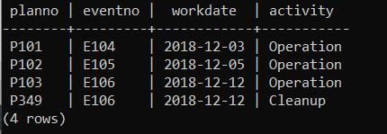

SELECT planno, eventplan.eventno, workdate, activity

FROM facility, eventrequest, eventplan

WHERE facility.facno = eventrequest.facno

AND eventrequest.eventno = eventplan.eventno

AND facname = 'Basketball arena'

AND workdate BETWEEN '2018-12-01' AND '2018-12-31';